# What is Two pointer

* algorithmic approach used in programming
* It involves using two pointers that traverse an array or a linked list simultaneously
* The pointers can move through the data structure from different positions or at different speeds, depending on the specific problem requirements.
* eliminate the need of without using nested loops. or you can use it where nested loop is required
* eliminating the need for nested loops
* **We Process Two elements per loop instead of just one**

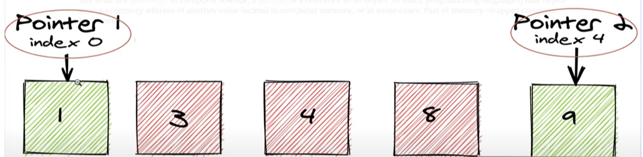

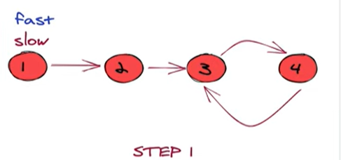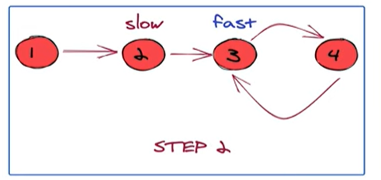

# Time complexity & Space Complexity

* time complexity is O(n)
* Space complexity is O(n)

# Data Structure used

* Sorted Array
* Sorted Linked List

# Important fact

* Data structure must be sorted
* Reduce Time Complexity from O(n2) to O(n)
* **We Process Two elements per loop instead of just one**
* One Outer While loop + 3 inner If loop

# Use Case

* find a specific pair of elements, a subarray, or a pattern within an array or linked list that meets certain conditions

# two types of two-pointer approaches

## Two pointers moving towards each other (or the "slow" and "fast" pointers)

* + you usually start with two pointers, one at the beginning (slow) and another at the end (fast) of the array or list
  + The pointers then move towards each other (inwards) until they meet or fulfill a specific condition

## Two pointers moving in the same direction

* + you typically start both pointers from the beginning of the array or list.
  + One pointer advances at a faster rate than the other based on the problem's requirements

# Two pointer Template

* First While loop
* Three If loop
  + First If loop – check condition and return
  + Second if loop increment left pointer counter
  + Third If Loop decrement right pointer counter

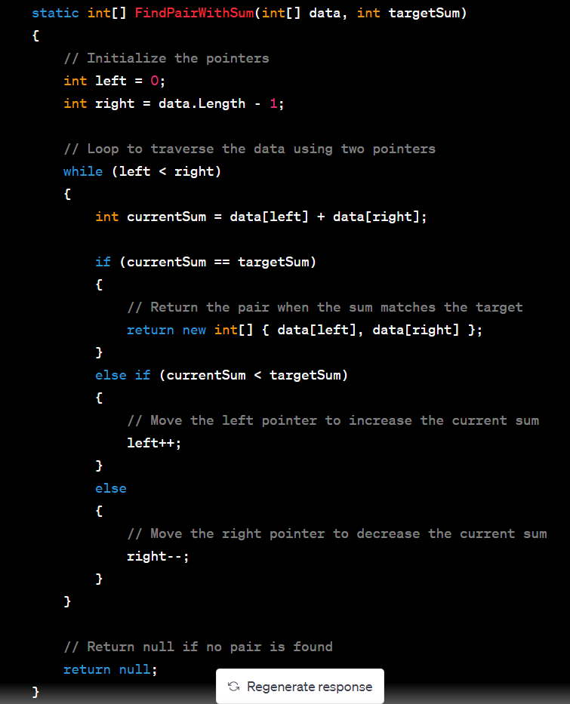

# Code based on two pointer

## Easy

* <https://leetcode.com/problems/two-sum/>
* <https://leetcode.com/problems/remove-duplicates-from-sorted-array/>
* <https://leetcode.com/problems/reverse-string/>
* <https://leetcode.com/problems/valid-palindrome/>

## Medium

* <https://leetcode.com/problems/container-with-most-water/>
* <https://leetcode.com/problems/3sum/>
* <https://leetcode.com/problems/longest-substring-without-repeating-characters/>
* <https://leetcode.com/problems/linked-list-cycle/> - fast and slow pointer

## Hard